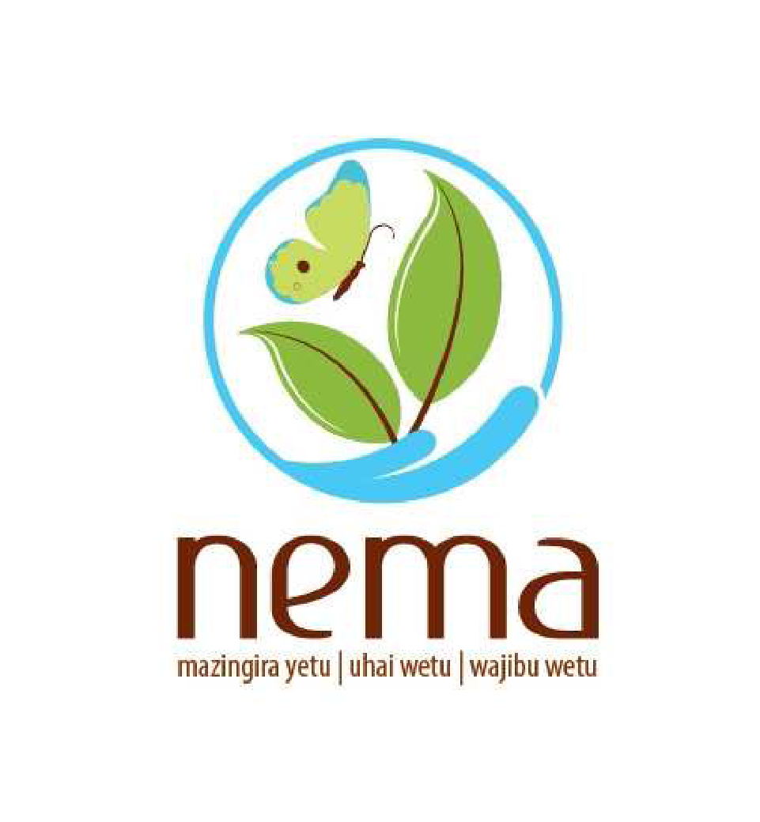
THE NATIONAL ENVIRONMENT MANAGEMENT AUTHORITY

VETTING CRITERIA FOR REGISTERED ENVIRONMENTAL EXPERTS

SUBMITTED TO

ENVIRONMENTAL MANAGEMENT, CONSERVATION AND TECHNICAL COMMITTEE OF THE BOARD

OCTOBER 2020

- INTRODUCTION
The Authority is mandated to register environmental experts who undertake Strategic Environmental Assessment (SEA), Environmental Impact Assessment (EIA) and Environmental Audit (EA) studies. These reports prepared by experts are submitted to the Authority for review.
The Registration process has been going on since 2003 and a total of over 11,000 experts have been registered. There are three (3) categories of experts namely Lead, Associates and Firms of experts. The EIA /EA Regulations of 2003 require that each category meets certain minimum qualifications before registration.
However, the authority has experienced cases of non-compliance with the provisions of the Code of Practice and Professional Ethics (CoPPE) issued by the Authority in line with regulation 13(3) of the Environmental (Impact assessment and Audit) regulations, 2003. The CoPPE provides a system of nurturing competence, knowledge, professional conduct, consistency, integrity and ethics in the carrying out of environmental assessment studies.
Environmental Experts Advisory Committee (EEAC) has been taking appropriate albeit piecemeal disciplinary action with respect to professional misconduct of an experts.

- JUSTIFICATION

The Authority in the last financial year (2019/2020) planned to undertake the following activities;
(i) vetting of registered environmental experts
(ii) review of the experts’ register
The objective of the activities is to streamline the registration process and ensure that good governance is promoted as the experts undertake their roles.
The NEMA Board of Management directed that the activity be undertaken by the Management through a select committee comprising of officers from the Authority.

- METHODOLOGY FOR VETTING

A vetting panel shall be constituted by the Management to undertake the assignment.

A score sheet shall be developed by the vetting panel on the above-mentioned areas of interest.

The methodology to be applied shall be as follows;
- Review of experts personal files
- Review of Environmental Experts Advisory Committee reports.
- Review of selected individual SEA/EIA/EA files
- One-on-one interviews with the experts

- CRITERIA FOR VETTING
Key principles of good governance shall form the main criteria for vetting of Environmental experts. This will provide system to screen, measure and evaluate experts’ competency, job fit, cultural fit and work performance. Emphasis has been placed on Competence and Capacity, Ethical Conduct, Efficiency and Effectiveness, Rule of Law and Personality assessment as follows;

- Competence and Capacity

Qualifications

- Lead expert
A Lead Expert must have attained the following qualifications:
Level of Education | EIA Training | Curriculum Vitae | Years of Experience
PHD | Attach | comprehensive | 3
Masters | Attach | comprehensive | 5
Bachelors | Attach | comprehensive | 8

- Associate expert
An Associate Expert must have attained the following qualifications:
Level of Education | EIA Training | Curriculum Vitae | Years of Experience
Bachelors | Attach | Comprehensive | 6months
Higher National Diploma | Attach | Comprehensive | 1year

The associate expert must work under registered firms/ Lead Experts to gain experience before being registered as an Experts.

(c) Firms of experts

A firm of Experts must meet the following conditions;

- Must be registered in Kenya to offer environmental assessment expertise.
- Comprehensive firm profile indicating capacity of its directors, partners and associates to undertake environmental assessment and audit studies.
- Certificate of incorporation/certificate of business registration
- At least one Lead Expert providing their NEMA Registration Certificate and a Practicing License for the current year
- At least one Associate Expert NEMA providing their Registration Certificate and a Practicing License for the current year
- At least one lead expert should be a Director in the firm
- Foreign firms must demonstrate the contribution of local expertise

  - Relevant Field of Expertise

Environmental Studies, Biological Sciences, Chemistry, Engineering (Civil, Agricultural, Water, Process/Chemical), Geography, Earth Sciences, Biophysical Sciences, Natural Sciences, Environmental Socio-Cultural Studies, Environmental Law or any other field approved by the Authority on the recommendation of a Professional Body or the Environmental Expert Advisory Committee.

  - Training Requirements

- Training in EIA from recognized institution and on NEMA approved curriculum for at least three (3) weeks full time by NEMA accredited training institution;
- Evidence of training must be ascertained in EIA certificate;
- Consideration for a universal name for the course offered in Kenya. Specific key words for the same course offered overseas. E.g. Integrated Environmental Assessment and Audit?
- Consideration for EIK to offer refresher courses /trainings on new guidelines for EIA/EA/SEA

  - General Competency Assessment
Assess the expert general knowledge of their role in ensuring clean and healthy environment as they undertake the environmental assessment studies.

- Ethical Conduct & Professionalism
Apart from the ascertaining that these experts qualify academically and in terms of experience, the vetting will also include but not limited to;
- Any disciplinary Records;
- Quality of Environmental Assessment Reports
- Have they prepared an EIA that was later cancelled or suspended for presenting false or misleading information to the Authority;
- Has the expert been signing a report for submission while he/she have not participated in developing?
- Has the expert been involved in inadequate disclosure of information in an environmental assessment report?
- Any other misconduct reported contrary to the code of Practice and Professional Ethics.

- Efficiency and Effectiveness
- Timeliness in responding to technical instructions and/or issues raised by the authority.
- Adherence to the plan of action as contained in the approved Terms of Reference

- Rule of Law
- Any legal issues, e.g. did the EIA lead to court cases/ NET that can be attributed to purely to the expert;
- Expert involvement in any criminal case?
- Certificate of Good Conduct from the DCI
- Valid Tax Compliance certificate from KRA
- Clearance Certificate from a Credit Reference Bureau
- Certificate of Compliance from HELB
- EIK Certificate

- Personality Assessment
Measuring “soft” attributes including but not limited to ambition, humility, respect, emotional intelligence, responsiveness, empathy and drive.

- Grading
Out of the possible maximum score of 100 marks, the pass mark will be 70 marks which means the expert will be retained in the register. For those who score lower marks, several recommendations will be given including undertaking refresher course.

- VETTING SCHEDULE
S/  No. | Activity | Dates | Action By; | Requirements
1. | Approval of vetting criteria by the Management | 28/9/2020 | Director General | Management Paper (staff time)
2. | Approval of vetting criteria by Board of Management | 22/10/2020 | Director General | Board Paper (staff time)
2. | Fact finding mission | 2/11/2020 to 9/11/2020 | Vetting Committee | Finances /Staff time
4. | Interviews with the experts | 10/11/2020 to 11/12/2020 | Vetting Committee | Finances /Staff time
5. | Report-writing (A retreat for compilation of the information) | 14/12/2020 to 20/12.2020 | Vetting Committee | Finances /Staff time
6. | Report submission | 22/12/2020 | Vetting Committee | Finances/Staff time

- REQUESTED ACTION
The committee is requested to:
- guide and recommend the approval of the vetting criteria.
- recommend the approval of the budgetary requirement to undertake the assignment.

Mamo B. Mamo
DIRECTOR GENERAL

